URL: https://adityabirlahospital.com/blogs/boosting-immunity-against-rainy-season-illnesses/

Meta Title: Your Guide to Monsoon Immunity Boosting | ABMH

Meta Description: Your guide to boosting immunity with smart food choices, hygiene tips, and wellness routines to help prevent common rainy season diseases.

Boosting Immunity: Your Shield Against Rainy Season Illnesses

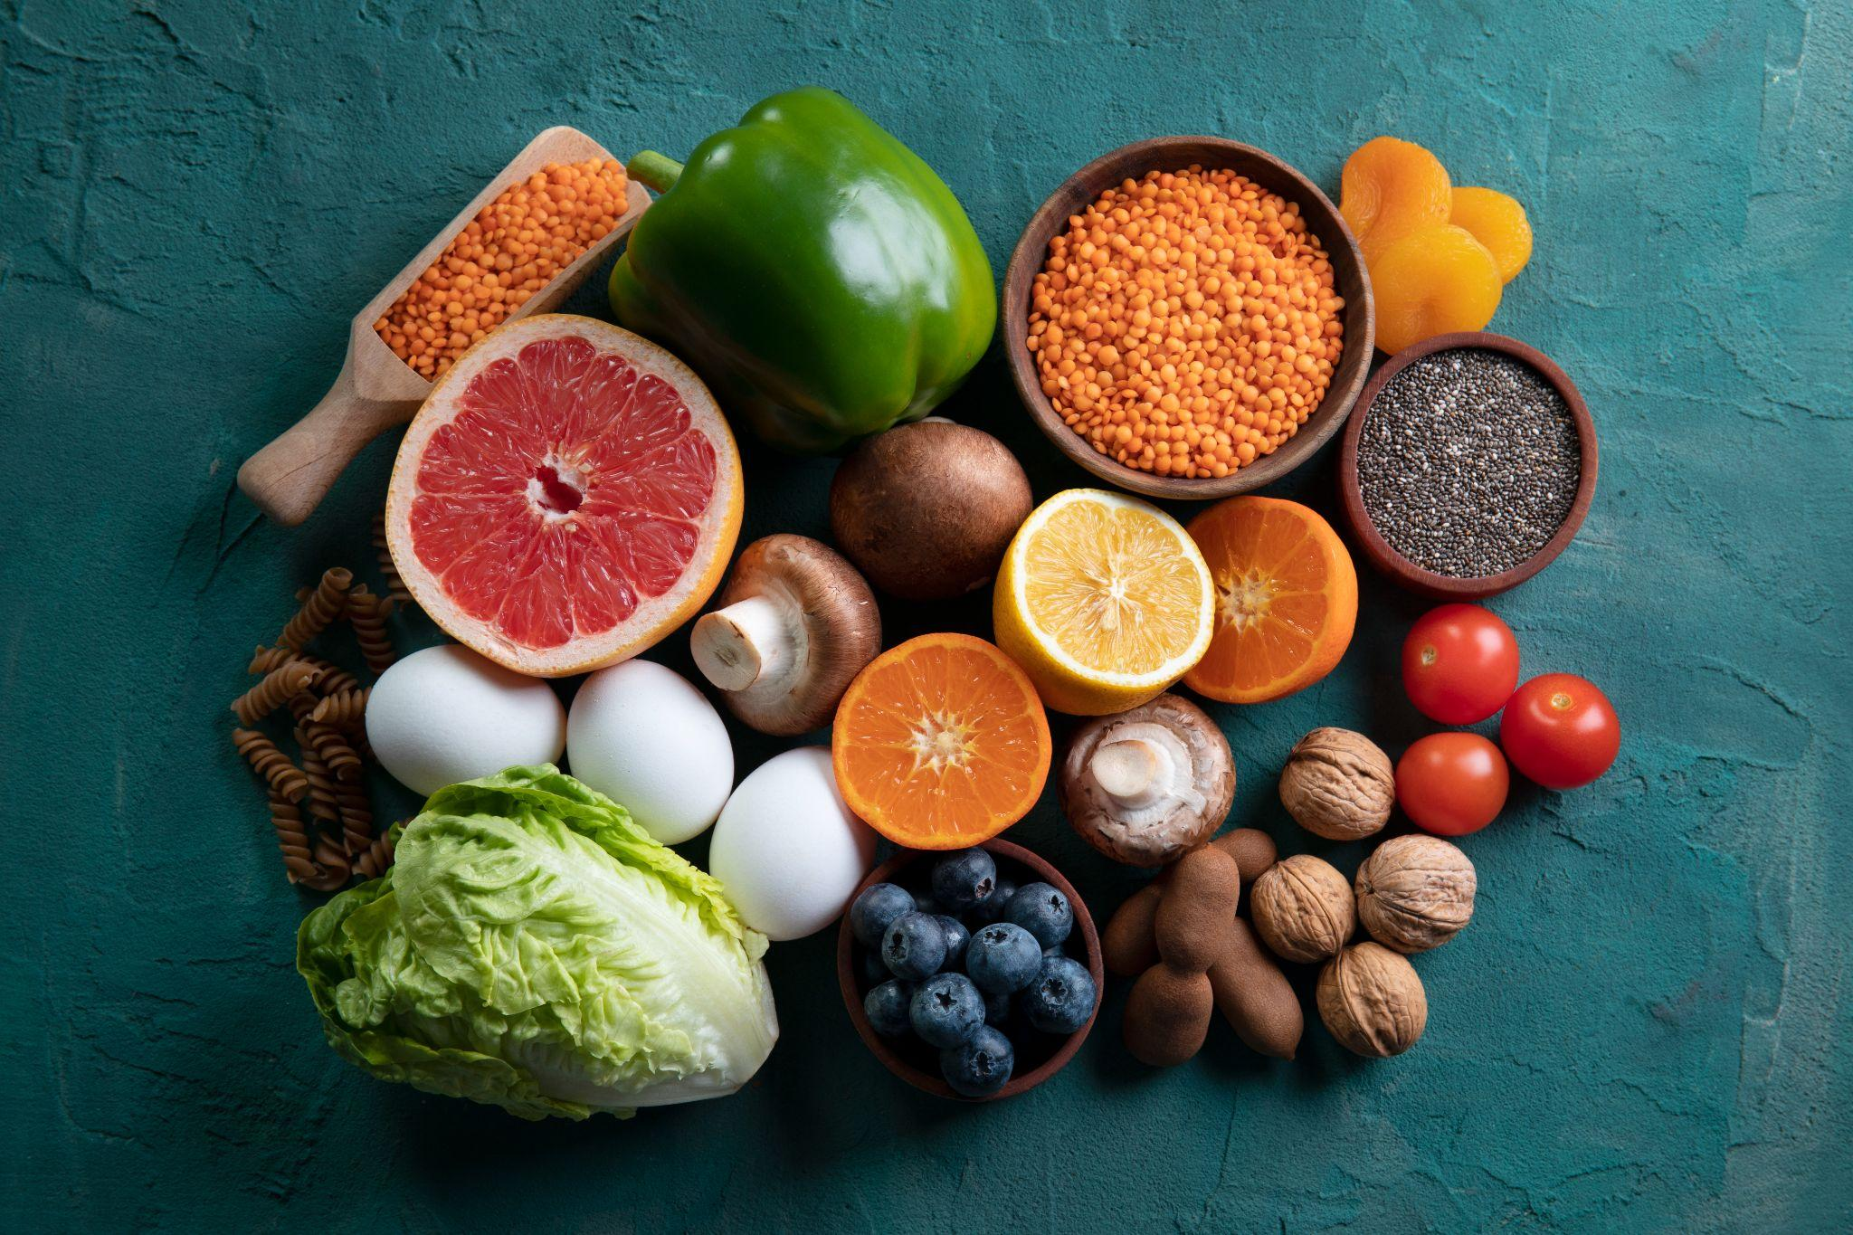
When the rain starts falling and the cool breeze rolls in, it’s a refreshing break from the heat—but it also brings along a host of seasonal health issues. From colds and flu to stomach infections and mosquito-borne diseases, the monsoon season is a time when your immune system needs to be at its best.
But don’t worry—with the right habits and awareness, you can enjoy the rainy season without falling sick. Here’s your complete guide to boosting immunity and protecting yourself and your loved ones during the monsoon.
Why Immunity Matters More in the Rainy Season
During monsoon, fluctuating temperatures and high humidity create the perfect breeding ground for bacteria, viruses, and fungi. Waterlogging, stagnant water, and dampness in the air allow illnesses to spread easily.
Common monsoon illnesses include:
- Colds, coughs, and throat infections
- Viral fevers
- Diarrhea and food poisoning
- Dengue and malaria
- Skin infections and fungal issues
Your immune system is your body’s natural defense mechanism that fights off these threats. Keeping it strong is your best bet to stay healthy through the season.
1. Eat the Right Foods
What you eat plays a major role in building a strong immune response.
Include:
- Vitamin C-rich fruits: Oranges, lemons, guava, and amla help fight infections.
- Green leafy vegetables: Spinach, methi, and curry leaves offer antioxidants.
- Spices like turmeric, ginger, and garlic: These have powerful anti-inflammatory and antibacterial properties.
- Fermented foods and probiotics: Yogurt, buttermilk, and pickles support gut health.
- Warm soups and broths: Easy to digest and full of nutrients.
Avoid:
- Raw or street food
- Reheated or stale food
- Excess sugar and oily snacks
- Unboiled or untreated water
2. Stay Well Hydrated
Water helps flush out toxins and supports every system in your body, including immunity.
- Drink at least 7–8 glasses of clean, filtered or boiled water daily.
- Include herbal teas like tulsi, ginger, or green tea.
- Coconut water and fresh fruit juices (made at home) are great options too.
3. Keep Moving—Even if Indoors
A sedentary lifestyle can lower your immunity over time. Don’t skip daily movement even during rain.
- Do simple home workouts: Yoga, stretching, or online fitness classes.
- Climb stairs or do bodyweight exercises.
- Even 20–30 minutes a day helps improve circulation and reduce stress.
4. Prioritize Rest and Sleep
- Try to get 7 to 9 hours of quality sleep each night.
- Stick to a regular sleep schedule.
- Avoid screens before bedtime, and keep your room cool and dark.
5. Keep Clean and Practice Hygiene
- Wash hands regularly with soap.
- Keep your surroundings clean and dry.
- Avoid walking in dirty water.
- Use mosquito repellent and window nets.
6. Dress Smart and Stay Dry
- Always carry an umbrella or raincoat.
- Change out of wet clothes immediately.
- Wear light, breathable fabrics.
7. Use Natural Remedies Wisely
- Tulsi: Drink tulsi tea or chew fresh leaves.
- Ginger and honey: Good for sore throats.
- Haldi milk: Great for its anti-inflammatory benefits.
8. Don’t Forget Vaccinations and Supplements
- Consider getting the flu vaccine.
- Take doctor-approved supplements like vitamin C, D, or zinc.
- Always consult a healthcare professional before taking supplements.
9. Consult Experts When Needed
- Don’t ignore symptoms like fever or stomach upset.
- Visit a trusted Internal Medicine Specialist.
- In Pune, consult the best Internal Medicine Hospitals for timely care.
Quick Monsoon Immunity Checklist:
- Eat fruits and veggies
- Drink clean water
- Exercise regularly
- Sleep 7–9 hours
- Avoid junk food
- Use mosquito protection
- Stay dry and clean
- See a doctor when sick
Final Thoughts
With the right food, habits, and hygiene, you can stay healthy and enjoy the beauty of the season. Your immunity is your invisible armor—keep it strong with these simple changes. And if you're ever unsure, consult an internal medicine specialist in Pune for expert advice.
Stay strong. Stay dry. Stay healthy. 🌧️💪

